HYPOTHESIS ASSIGNMENT

TeleCall uses 4 centers around the globe to process customer order forms. They audit a certain % of the customer order forms. Any error in order form renders it defective and has to be reworked before processing. The manager wants to check whether the defective % varies by centre. Please analyze the data at *5%* significance level and help the manager draw appropriate inferences

DATASETS: **CustomerOrderForm.mtw**

TEST: chi-square test

Code:

cof<-read.csv(file.choose()) # customer_order(unstacked).xlsx

View(cof) # countries are in their own columns; so we need to stack the data

stacked_cof<-stack(cof)

attach(stacked_cof)

View(stacked_cof)

table(stacked_cof$ind,stacked_cof$values)

chisq.test(table(stacked_cof$ind,stacked_cof$values))

OUTPUT:

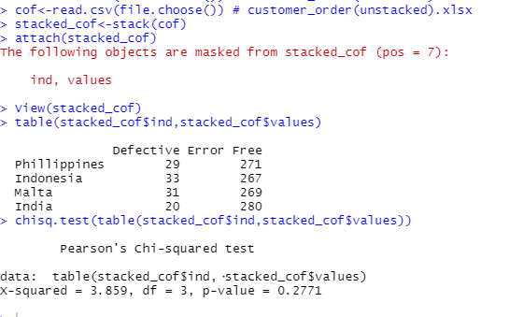

Here, we Conclude that the P value is Greater than 0.05 (p>0.05). Accept Null Hypothesis.

A F&B manager wants to determine whether there is any significant difference in the diameter of the cutlet between two units. A randomly selected sample of cutlets was collected from both units and measured? Analyze the data and draw inferences at 5% significance level. Please state the assumptions and tests that you carried out to check validity of the assumptions.

DataSets : **Cutlets.mtw**

Test: Two-sample t-test

Code:

setwd("C:\\Users\\sunil\\Downloads\\Hypothesis Testing assignment")

library(readxl)

install.packages("readxl")

clutles<-read.csv(file.choose())

View(clutles)

attach(clutles)

shapiro.test(Unit.A)

shapiro.test(Unit.B)

var.test(Unit.A,Unit.B)

t.test(Unit.A,Unit.B,alternative = "two.sided",conf.level = 0.95,correct=TRUE)

P value>0.05 so, accept Null hypothesis

Output:

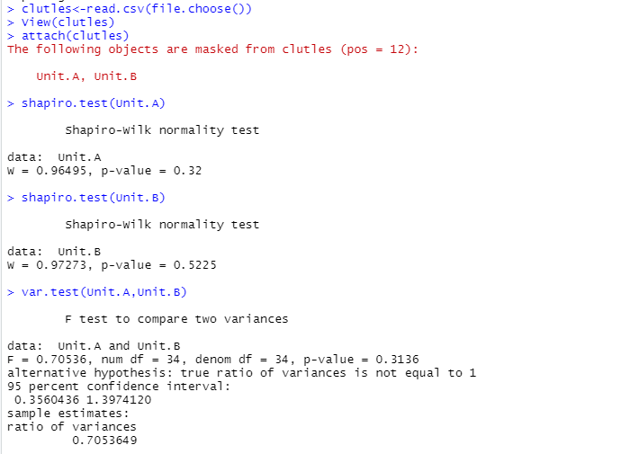

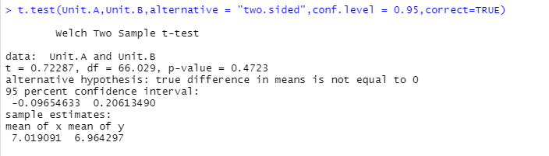

Here, p>0.05 which is 0.4723 Accept null hypothesis

Sales of products in four different regions is tabulated for males and females. Find if male-female buyer rations are similar across regions.

DATASETS:Buyerratio.csv

Code:

byrratio<-read.csv(file.choose())

View(byrratio)

attach(byrratio)

table(Observed.Values,East)

chisq.test(table(Observed.Values,East))

table(East,West)

chisq.test(table(East,West))

OUTPUT:

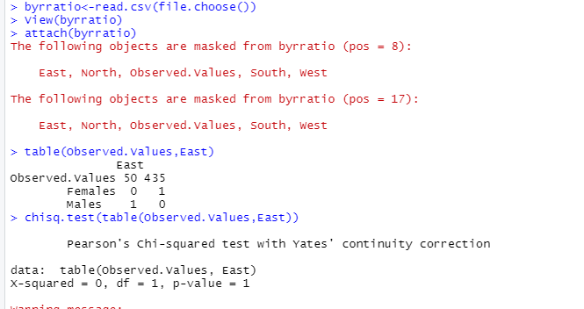

Here, P value is greater than 0.05 accept null hypothesis

Fantaloons Sales managers commented that *%* of males versus females walking in to the store differ based on day of the week. Analyze the data and determine whether there is evidence at *5 %* significance level to support this hypothesis.

Minitab File: **Fantaloons.mtw**

Test: Proportion test

Code:

fan<-read.csv(file.choose())

View(fan)

attach(fan)

table1 <- table(Weekdays,Weekend)

table1

?prop.test

prop.test(x=c(66,47),n=c(233,167),conf.level = 0.95,correct = FALSE,alternative = "two.sided")

OUTPUT:  
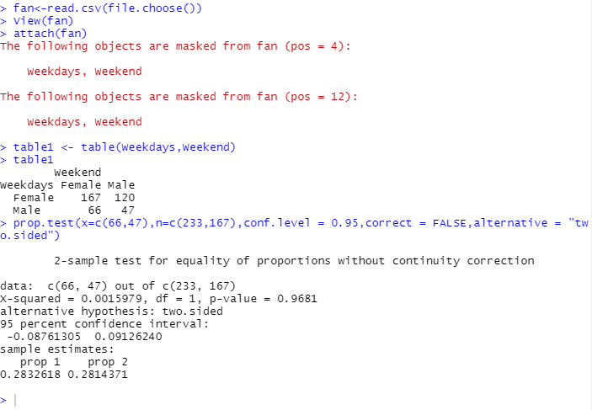

Here, p>0.05 which is 0.9681 so accept null hypothesis

A hospital wants to determine whether there is any difference in the average Turn Around Time (TAT) of reports of the laboratories on their preferred list. They collected a random sample and recorded TAT for reports of 4 laboratories. TAT is defined as sample collected to report dispatch. Analyze the data and determine whether there is any difference in average TAT among the different laboratories at 5% significance level.

Minitab File: **LabTAT.mtw**

Code:

labtat<-read.csv(file.choose())

View(labtat)

attach(labtat)

install.packages("car")

library(car)

leveneTest(Laboratory.1,Laboratory.2,data=labtat)

Anova_results <- aov(Laboratory.1~Laboratory.2,data=labtat)

summary(Anova_results)

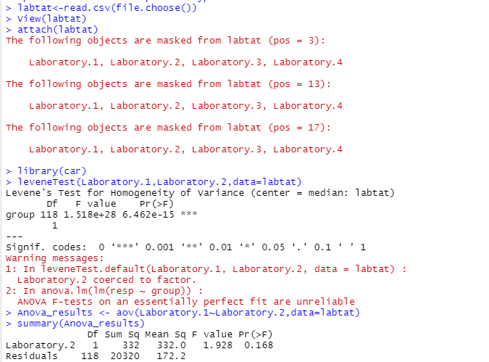

Here, p >0.05 which is 0.168 accept NULL Hypothesis